Human Computer Interaction - Politecnico di Milano

Main Project - Math Dots (Kids Game)

Prof. Franca Garzotto

Group - The Foreigners

Cássio Scofield - scofieldcassio@gmail.com
Erik Hane - ehane@kth.se

Introduction

Connect dots is a very famous childrens game. It helps children to count and learn the alphabet. The game is fairly simple you need to connect adjacent dots following a defined pattern that is usually numbers or letters in the correct order. After connecting the dots a picture is formed.
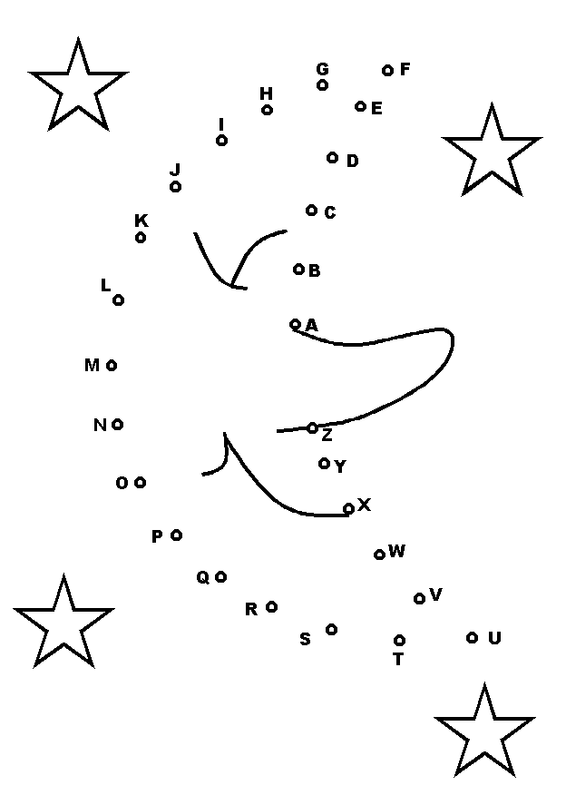  Paper Connect Dots (alphabetical order) | 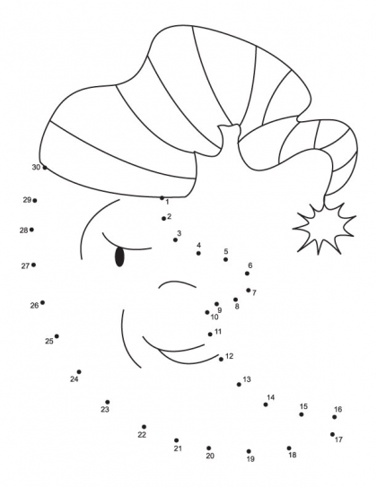  Paper Connect Dots (numerical order)

Game details: http://en.wikipedia.org/wiki/Connect_the_dots

Objective

Create a tablet/smartphone version of the connect the dots game which can not only teach counting but also simple math such as addition, subtraction, multiplication, division, etc. The game should also support multiplayer function, both cooperative and competitive mode.

Target Audience

The game is meant to be an educational game for children who are in the process of learning counting and basic arithmetic with small numbers. This means the game primarily aimed towards school children in ages of 3-9. Even so the game is designed to make this process a fun and interactive experience, containing features such as high scores, teamwork and competing.

Technology

We chose to use the Android operational system because we have Android devices to test it on. Although using the Android operational system we decided not to use the default Android SDK, which uses the Java Language. Instead we opted to use the Moscrif platform which uses Javascript as its programming language. The platform supports not only Android devices but also iOS, Symbian and Bada operating systems, which would make it easier to “recompile” the application for any of these devices and port the program to any other modern operating system, given that most of them support Javascript as a secondary Language.

Interaction

The interaction with game will be touchscreen. The player selects the dots by clicking near them and a line will be formed between the selected dot and the previous one if the selected dot is correct. If the selected dot is not the correct one this will be indicated to the player.

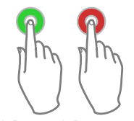
Feedback indication (Left-correct/Right-wrong)

Singleplayer

In the singleplayer mode the player gets a higher score the faster he completes the level, but gets penalized if he makes mistakes. The singleplayer mode also includes a highscore system, which alerts the player when he has achieved a high score. The highscore page shows all best scores achieved by the player in the singleplayer, organized by game mode (addition, subtraction, multiplication, etc).

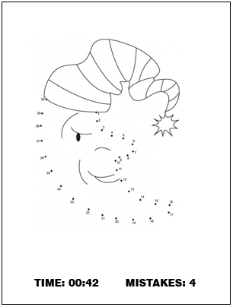
Simplied Singleplayer mode view

Cooperative Multiplayer

In the cooperative multiplayer mode, both players share the same screen. To enhance teamwork, although each player has his separate screen, they draw collaboratively the same picture. When the game is completed the score is computed as in the singleplayer mode.

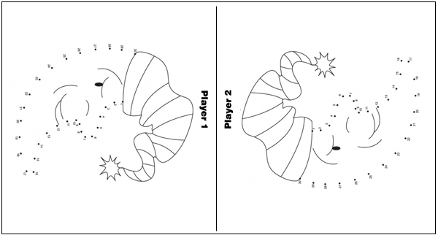
Simplified Cooperative Multiplayer mode view

Competitive Multiplayer

In the competitive multiplayer mode, both players share the same screen to form each his separate shape, with similar difficulty level, in this game mode the one who completes first wins. The system keeps track of the win count of each player to make the competition more interesting.

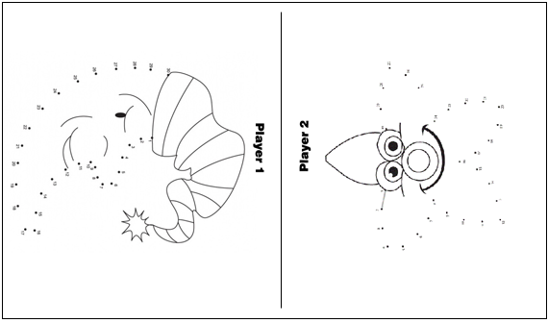
Simplified Competitive Multiplayer mode view

Game Difficulty Levels

The game has six different difficulty levels based on the operations that the user has to perform in order to figure out the next dot of the figure, they are:

- Counting
- Addition
- Subtraction
- Multiplication
- Division
- Random (all of the above mixed)

Gameplay and Screenshots

Here follows a short walkthrough of the game and its content.

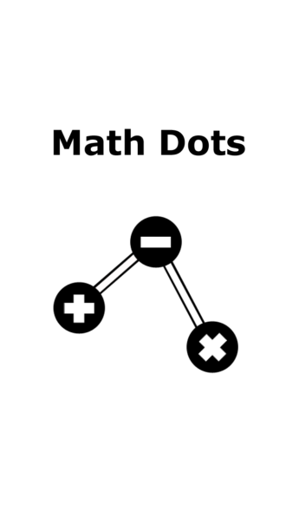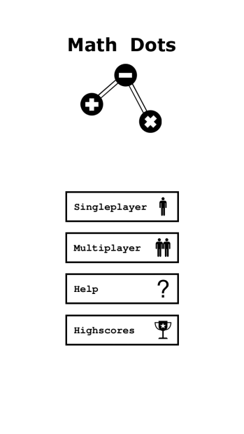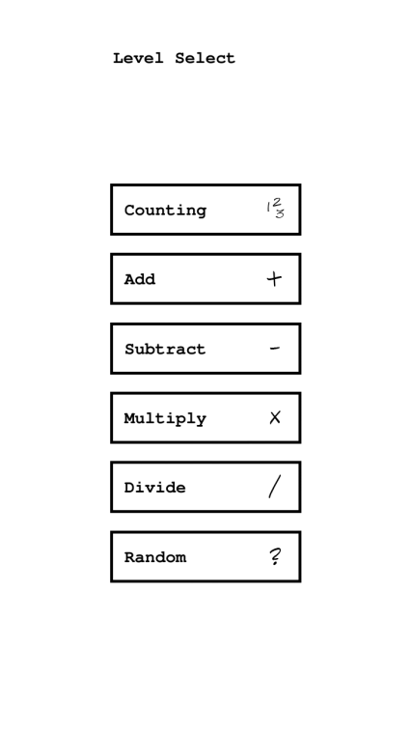
Welcome screen - At the start up of Math Dots the player is welcomed by the game logo which follows an overall theme of simple and minimalistic design.
Main menu – In the main menu the player can acess the single and multiplayer gaming instances, aswell as the help section and highscore.
Level select – In both the single and multiplayer a game mode is chosen. The choices are counting, add, subtract, multiplication and division. This step also contains a random function which will randomize the selection.

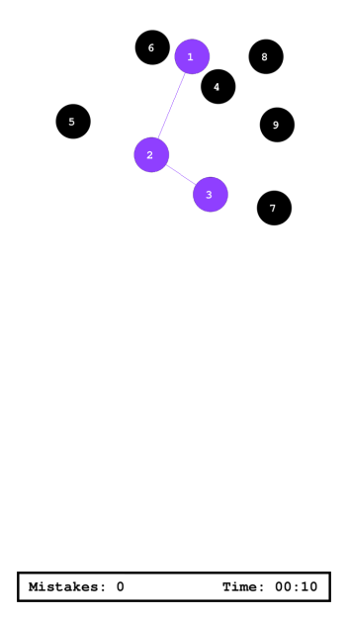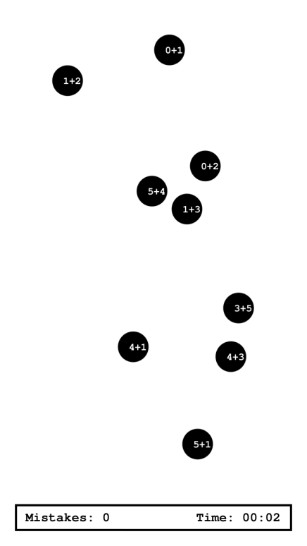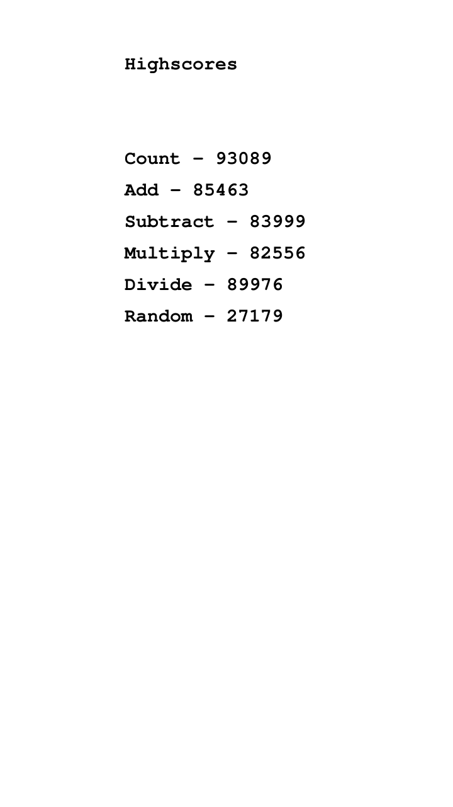

Gameplay singleplayer, counting - The goal in Math Dots is to complete each math puzzle by clicking the dots in the right order and create the correct sequence. In this example the category is counting, and the puzzle is solved by doing the count from 1 to 9 in order. If the clicked dot is correct the dot will light up green, otherwise red.
Gameplay singleplayer, adding - In this game the category is adding and the player must do the math in each dot to figure out the sequence. The first dot is: (0+1) since it equals 1. The second is 0+2 etc. The procedure is similar in all the other categories.
Highscore - After each game the player is given a score based on time and number of mistakes. The best results are saved in the high score.

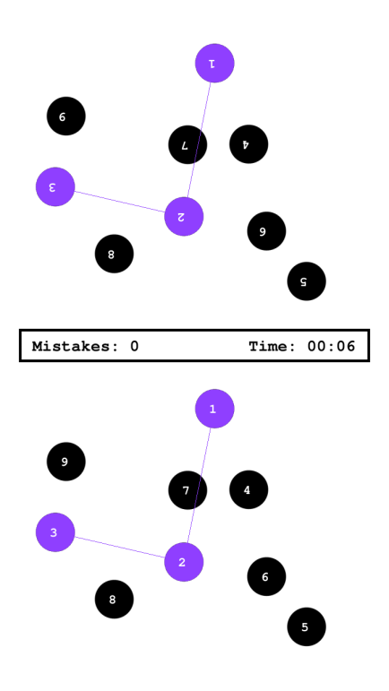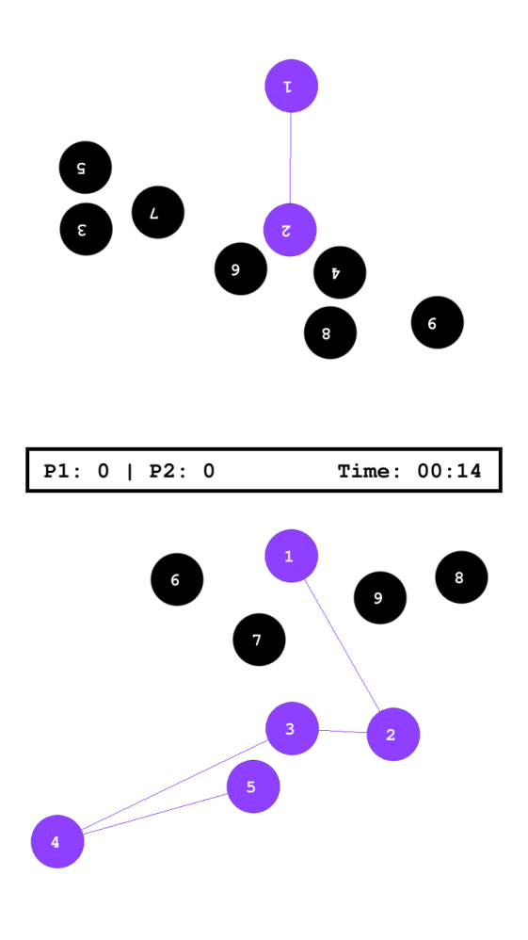
Gameplay multiplayer, Cooperative - In the multiplayer two people play together on a split screen. Cooperative mode means that two players work together solving the same puzzle.
Gameplay multiplayer, Versus In versus mode the players competes in finishing the puzzle first and with the least amount of mistakes.

Further Enhancements

Some features that could be implemented enhance the game experience.

- More difficulty levels - To add more variety to the game, each game mode (counting, add etc.) could be complemented with difficulty levels. The different levels may vary the number of operations, number of dots, etc.

- Connect devices - To make it possible to play multiplayer on separated devices.

- Picture creation with the dots - To enhance the game experience for young children the dot patterns created in each math puzzle shall when connected correctly create a pattern that makes out a figure or picture. This would make each puzzle more rewarding to complete. Se example below.

